1. Select 1 Creational Design Pattern from the following list

* Singleton
* Composite
* Decorator
* Template Method

1. Which design pattern should you use to create a complex object?

* Abstract Factory
* Template Method
* Builder
* Singleton

1. What Design Pattern is used in the following UML diagram?

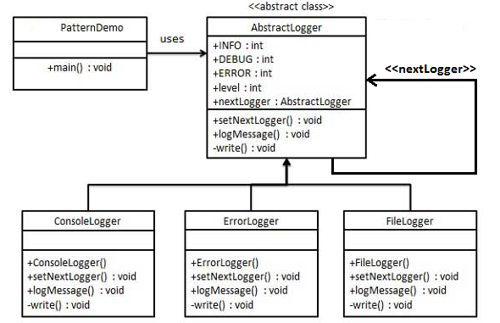

* Composite
* Template Method
* Strategy
* Chain of Responsibility

1. Strategy pattern is used to:

* Switch algorithm at run time
* Switch algorithm at compile time
* To replace part of execution code at runtime
* Focus on architecture of the system

1. Which Design Pattern can be observed in the operation of a taxi company?

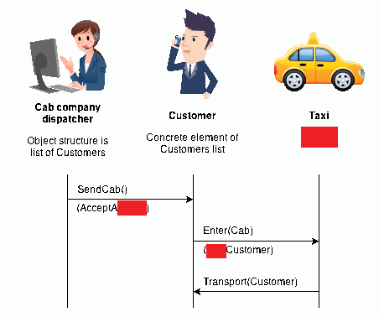

* Memento
* State
* Observer
* Visitor

1. Which Design Patterns represents the following Class Diagram?

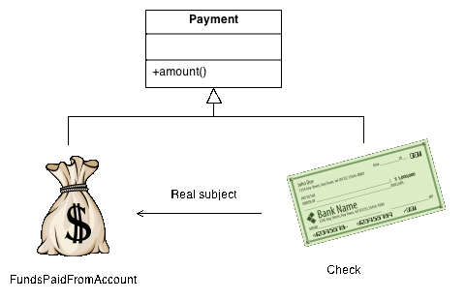

* Proxy
* Bridge
* Command
* Memento